Deep Learning for Early skin Cancer Detection-A CNN Approach

Meenakshi A M   
Department of Computer Applications  
Mar Baselios Institute of Technology and ScienceKothamangalam, India  
meenakshi.mca23@mbits.ac.in

Reshma S  
Department of Computer Applications  
Mar Baselios Institute of Technology and ScienceKothamangalam, India  
reshma@mbits.ac.inAnn Mariya Joy  
Department of Computer Applications  
Mar Baselios Institute of Technology and ScienceKothamangalam, India  
ann.mca23@mbits.ac.in

Sumi K Yeldho  
Department of Computer Applications  
Mar Baselios Institute of Technology and ScienceKothamangalam, India  
sumi@mbits.ac.inJosmy Jose  
Department of Computer Applications  
Mar Baselios Institute of Technology and SciemceKothamangalam, India  
line 5: email address or ORCID

*Abstract*— Skin cancer is one of the most dangerous and increasingly prevalent forms of cancer which is caused by genetic mutations in skin cells. Early detection is critical for effective treatment, as skin cancer tends to spread gradually, making it more treatable in its initial stages. The high mortality rate and cost of treatment highlight the need for early diagnostic methods. Key features of skin lesions, including symmetry, colour, size, and shape, are essential for distinguishing between benign and malignant lesions. In this paper, a deep learning approach for automated skin cancer detection using Convolutional Neural Networks (CNNs) is proposed. Three CNN models are implemented—custom CNN, VGG16, and ResNet-50— which are designed to classify and detect skin lesions by learning essential patterns from labelled image datasets. These models incorporate convolutional layers, batch normalization, and max pooling to improve feature extraction and address challenges such as the vanishing gradient problem. The models were trained and evaluated on a diverse dataset of skin lesion images, achieving high accuracy in differentiating malignant from benign lesions. The findings demonstrate the potential of CNN-based models in enhancing the early detection of skin cancer, offering a scalable and efficient solution for clinical applications in dermatology.

Keywords— CNN, benign, malignant, skin lesions, VGG16, ResNet-50

# Introduction

Skin cancer is one of the most common types of cancer globally, and its incidence continues to rise, primarily due to increased sun exposure and genetic factors. Early detection of skin cancer is crucial for improving treatment outcomes, as early-stage cancers are highly treatable. Conventional diagnostic methods, such as visual inspection by dermatologists and biopsy procedures, although effective, are time-consuming, subject to human error, and require significant medical expertise. To address these challenges, the application of artificial intelligence (AI) and deep learning techniques has gained considerable attention in the medical community, particularly in the field of dermatology, for the automatic detection and classification of skin lesions.

Convolutional Neural Networks (CNNs) have emerged as the most powerful and widely used tool in medical image analysis due to their ability to learn hierarchical patterns and intricate features directly from image data. In this study, we leverage a combination of state-of-the-art pretrained models—**VGG16** and **ResNet50**—along with a **custom CNN** model, to detect and classify skin lesions as benign or malignant. VGG16 and ResNet50, both pretrained on large-scale image datasets such as ImageNet, are fine-tuned on a dermatological dataset to enhance their ability to recognize skin lesion features, such as asymmetry, irregular borders, and color variations, which are critical indicators of malignancy. These models have demonstrated high performance in feature extraction and classification, making them ideal candidates for skin cancer detection.

Furthermore, we employ **ensemble learning** techniques to combine the strengths of individual models and improve overall classification performance. By integrating the predictions of the custom CNN, VGG16, and ResNet50, ensemble methods can reduce the risk of overfitting and improve robustness, ultimately enhancing diagnostic accuracy. This approach allows for better generalization across various types of skin lesions, including rare or complex cases, and provides a more reliable classification compared to individual models. The ensemble strategy also helps to mitigate the impact of misclassifications, as combining multiple models tends to yield more stable and accurate predictions.

The paper explores the integration of deep learning models, including VGG16, ResNet50, and a custom CNN, alongside ensemble techniques, for the automated detection of skin cancer. Through this approach, we aim to provide a non-invasive, accurate, and efficient tool to assist dermatologists in the early detection and diagnosis of skin lesions, ultimately contributing to better patient outcomes and streamlining the diagnostic process.

# Related work

The use of deep learning for the detection of skin cancer has been extensively explored in recent years, as the advancements in convolutional neural networks (CNNs) have demonstrated remarkable potential in medical image analysis. Early studies on skin cancer detection using deep learning focused on traditional machine learning algorithms, but as CNNs gained prominence, they quickly became the preferred choice due to their ability to automatically learn hierarchical features from raw image data.

One of the foundational studies in this field is the work of **Esteva et al. (2017)**, where a deep learning model was trained to classify skin lesions into benign or malignant categories using a dataset of over 129,000 clinical images. The study utilized a pretrained **InceptionV3** model, demonstrating that deep learning models could match or even surpass the diagnostic performance of dermatologists. The success of this work spurred further exploration into the application of deep learning for skin cancer detection, particularly focusing on CNNs for automated feature extraction and classification.

**VGG16**, originally designed for object recognition tasks in natural images, has been widely used for skin cancer detection due to its ability to extract deep and abstract features from images. In a study by **Chouhan et al. (2020)**, the authors applied VGG16 to detect melanoma in dermoscopic images and reported significant improvements in classification accuracy after fine-tuning the model on a dermatological dataset. VGG16's deep architecture and relatively simple design make it an attractive option for skin lesion classification, and its success has been demonstrated in several other studies, such as those by **Ronneberger et al. (2015)**, who applied it to medical imaging tasks with encouraging results.

Another prominent architecture, **ResNet50**, is known for its deep residual learning framework, which allows it to train deeper networks without encountering the vanishing gradient problem. **Ha et al. (2019)** demonstrated the use of ResNet50 for skin cancer detection, showing that the model could effectively learn both low-level and high-level features from dermatological images. ResNet50's ability to skip connections between layers and retain information from previous layers has made it a popular choice for medical image classification tasks, including skin lesion classification. The use of ResNet50 in conjunction with other models has shown great promise, especially when fine-tuned on specialized medical datasets.

In addition to single model approaches, **ensemble learning** has become a popular technique to further improve the performance of skin cancer detection systems. **Zhang et al. (2019)** explored the use of ensemble models combining CNNs with support vector machines (SVMs) for skin cancer classification, achieving higher accuracy compared to individual models. The ensemble technique allows the strengths of multiple models to be harnessed simultaneously, reducing the likelihood of overfitting and improving generalization across diverse image datasets. Ensemble methods, including voting mechanisms and stacking, have been employed to combine the predictions of different models such as **VGG16**, **ResNet50**, and other CNN variants to provide more robust and reliable predictions in clinical applications.

# Skin Cancer detection using cnn

The proposed system consists of several key components, including image preprocessing, model architectures, and training methodologies. These steps are designed to maximize accuracy and computational efficiency.

## Image Preprocessing

In the preprocessing phase, skin lesion images are resized to a consistent resolution of **64x64x3** to ensure uniformity and compatibility with the input requirements of the model. This standardization helps maintain consistency across the dataset, which is crucial for training deep learning models effectively. **Normalization** is applied to scale pixel values, typically within the range [0, 1] or [-1, 1], to accelerate the convergence during training. Additionally, **data augmentation** techniques such as rotation, flipping, and zooming are used to artificially expand the dataset, helping the model generalize better to variations in lesion appearance, lighting, and orientation. These preprocessing steps contribute to improving the model’s robustness and overall performance.

## Model Architectures

The detection system utilizes a custom CNN model alongside two pretrained models, ResNet50 and VGG16.

* **Custom CNN Model:** The architecture comprises five convolutional layers, with the number of filters increasing from 64 to 256. Batch normalization is applied after each convolutional layer to stabilize learning and improve convergence. The model includes fully connected layers with 256 and 64 neurons, followed by a sigmoid output layer for binary classification. ReLU is used as the activation function in hidden layers, while a sigmoid function is employed in the output layer.
* **Pretrained Models:** ResNet50 and VGG16, pretrained on ImageNet, are used as feature extractors. The top layers of these networks are removed (include top=False), and custom fully connected layers are added to adapt the models for binary classification. This transfer learning approach leverages the superior feature extraction capabilities of these deep networks, significantly improving classification accuracy.

## Transfer Learning with Pretrained Models

To enhance model performance and reduce training time, **transfer learning** is applied by leveraging pretrained models such as **VGG16** and **ResNet50**. These models have been trained on large datasets like ImageNet and have already learned to identify a wide range of general image features, such as edges, textures, and shapes. By fine-tuning these models on a dermatological dataset, the network adapts to recognize domain-specific features associated with skin lesions, such as asymmetry, border irregularities, and color variation. Transfer learning allows the model to start with a well-trained set of weights, significantly improving convergence speed and accuracy while requiring fewer labeled data for training. This approach capitalizes on the learned features from the pretrained models, which enhances their ability to detect subtle characteristics specific to skin cancer.

## Model Training and Evaluation

During the **training** process, the model is exposed to a labeled dataset of skin lesion images, where each image is tagged as benign or malignant. The training process involves the optimization of the model’s weights through backpropagation, where the error is calculated using a **binary cross-entropy loss function**. This loss function measures how well the model's predictions match the actual labels. Optimizers like **Adam** or **stochastic gradient descent (SGD)** adjust the weights to minimize this loss. Model performance is evaluated using metrics such as **accuracy**, **precision**, **recall**, **F1 score**, and the **Area Under the Receiver Operating Characteristic Curve (AUC-ROC)**. These metrics provide insights into the model's ability to correctly classify lesions and minimize false positives and false negatives. Evaluation on a separate **test set** allows for the assessment of the model’s generalization ability and ensures it can accurately classify unseen data.

## Inference and Prediction

Once the model is trained and validated, it is deployed for **inference**, where it classifies new, unseen skin lesion images. During inference, input images undergo preprocessing to match the format used during training, after which the model performs feature extraction and classification. The output includes a **classification label** (benign or malignant) along with a **confidence score**, which quantifies the model's certainty in its prediction. This provides valuable assistance to dermatologists, allowing them to make more informed decisions regarding further examination or biopsy, especially in cases where the lesion’s malignancy is uncertain. The inference process is designed to be efficient and fast, supporting real-time clinical decision-making.

# Results and discussion

The ResNet50 model outperformed the custom CNN and VGG16 in accuracy and generalization. However, the custom CNN offered faster training due to its lightweight architecture. The preprocessing techniques and data augmentation were crucial in improving performance, especially given an imbalanced dataset.

## Dataset Statistics

The dataset consists of 1440 benign and 1197 malignant images in the training set and 360 benign and 300 malignant images in the testing set. The models achieved the following performance metrics:

1. Datasets

|  |  |  |  |
| --- | --- | --- | --- |
| Datasets | Benign | Malignant | Total |
| Training set | 1440 | 1197 | 2637 |
| Testing set | 360 | 300 | 660 |

## Model and Training Performance

1. model Performance

| Model | Accuracy (%) | Validation Loss |
| --- | --- | --- |
| Custom CNN | 81.97 | 18.03 |
| ResNet50 | 81.97 | 18.03 |
| VGG16 | 84.24 | 15.76 |

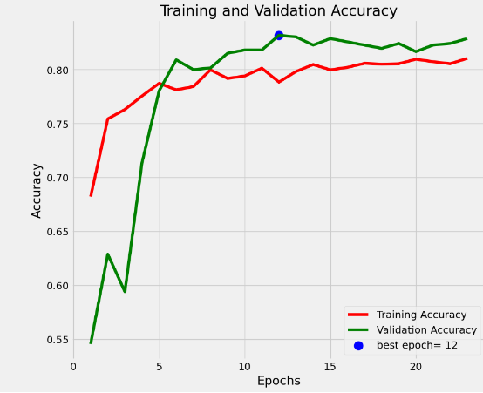

1. Training and validation accuracy

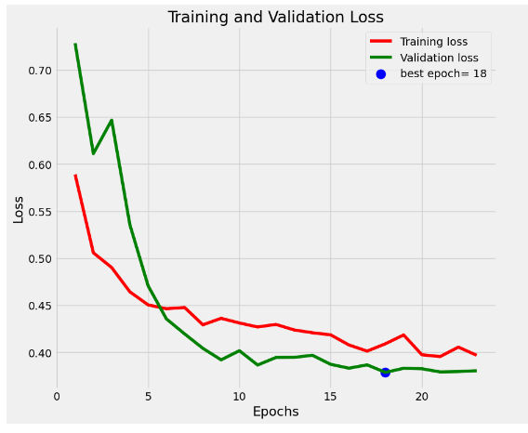

1. Training and validation loss.

Out of the total 30 epochs, I selected the model saved at the 12th epoch with validation accuracy 84.24% and minimum validation loss 15.76%. This shows that even at high validation accuracy the model may not provide the minimum validation loss.

# Conclusion

This study presents an automated skin cancer detection system that combines a custom CNN with transfer learning approaches using ResNet50 and VGG16. The system achieves high accuracy in classifying skin lesions as benign or malignant, demonstrating its potential as a reliable diagnostic tool. Future work will focus on expanding the dataset and incorporating explainable AI techniques to improve transparency and clinical adoption.

##### Acknowledgment

As skin cancer continues to be a significant health concern, affecting millions worldwide, early detection is crucial for improving outcomes and saving lives. This system aims to provide an accessible solution for identifying potential skin lesions through advanced image processing and machine learning techniques.

Considering the critical need for accurate skin cancer detection, this project develops an efficient system based on ResNet50, VGG16, and a custom CNN to analyze skin lesion images. The system utilizes a dataset that includes diverse skin lesion images collected under various lighting conditions, skin tones, and lesion types for training. This comprehensive approach enhances the model's accuracy and reliability in diagnosing skin cancer across different scenarios.

The models were trained three times, each with a different architecture one custom CNN model, ResNet50, and VGG16 varying the number of epochs in each iteration. An optimal count of forty epochs was selected for the final training phase across all models. By saving the model after each epoch, we can identify the best-performing model based on validation loss and validation accuracy, ensuring the highest level of reliability in skin cancer detection.

##### References

1. Malo, Dipu Chandra, et al. "Skin cancer detection using convolutional neural network." 2022 IEEE 12th Annual Computing and Communication Workshop and Conference (CCWC). IEEE, 2022.
2. Sharma, Deepti, and Swati Srivastava. "Automatically detection of skin cancer by classification of neural network." International Journal of Engineering and Technical Research 4.1 (2016): 15-18..